18/3/19
EXPERIMENT NO. 9:- To Study Any Web Testing Tool (Selenium)

Theory:
Selenium is a portable framework for testing web applications. Selenium provides a playback (formerly also recording) tool for authoring functional tests without the need to learn a test scripting language (Selenium IDE). It also provides a test domain-specific language (Selenese) to write tests in a number of popular programming languages, including C#, Groovy, Java, Perl, PHP, Python, Ruby and Scala. The tests can then run against most modern web browsers. Selenium deploys on Windows, Linux, and macOS platforms. It is open-source software, released under the Apache 2.0 license: web developers can download and use it without charge.

Components of Selenium:
Selenium is composed of several components with each taking on a specific role in aiding the development of web application test automation.

Selenium IDE-
Selenium IDE is a complete integrated development environment (IDE) for Selenium tests. It is implemented as a Firefox Add-On and as a Chrome Extension. It and allows for recording, editing, and debugging of functional tests. It was previously known as Selenium Recorder. Selenium-IDE was originally created by Shinya Kasatani and donated to the Selenium project in 2006. Selenium IDE was previously little-maintained. Selenium IDE began being actively maintained in 2018.
Scripts may be automatically recorded and edited manually providing autocompletion support and the ability to move commands around quickly. Scripts are recorded in Selenese, a special test scripting language for Selenium. Selenese provides commands for performing actions in a browser (click a link, select an option), and for retrieving data from the resulting pages.
The 2.x version of the Selenium IDE for Firefox stopped working after the Firefox 55 upgrade and has been replaced by Selenium IDE 3.x. However users can run the older Selenium IDE on some older Firefox versions (pre-Firefox 55) or try other alternative solutions

Selenium client API-
As an alternative to writing tests in Selenese, tests can also be written in various programming languages. These tests then communicate with Selenium by calling methods in the Selenium Client API. Selenium currently provides client APIs for Java, C#, Ruby, JavaScript and Python.
With Selenium 2, a new Client API was introduced (with WebDriver as its central component). However, the old API (using class Selenium) is still supported.

Selenium WebDriver-
Selenium WebDriver is the successor to Selenium RC. Selenium WebDriver accepts commands (sent in Selenese, or via a Client API) and sends them to a browser. This is implemented through a browser-specific browser driver, which sends commands to a browser and retrieves results. Most browser drivers actually launch and access a browser application (such as Firefox, Chrome, Internet Explorer, Safari, or Microsoft Edge); there is also an HtmlUnit browser driver, which simulates a browser using the headless browser HtmlUnit.
Unlike in Selenium 1, where the Selenium server was necessary to run tests, Selenium WebDriver does not need a special server to execute tests. Instead, the WebDriver directly starts a browser instance and controls it. However, Selenium Grid can be used with WebDriver to execute tests on remote systems (see below). Where possible, WebDriver uses native operating system level functionality rather than browser-based JavaScript commands to drive the browser. This bypasses problems with subtle differences between native and JavaScript commands, including security restrictions.
In practice, this means that the Selenium 2.0 API has significantly fewer calls than does the Selenium 1.0 API. Where Selenium 1.0 attempted to provide a rich interface for many different browser operations, Selenium 2.0 aims to provide a basic set of building blocks from which developers can create their own Domain Specific Language. One such DSL already exists: the Watir project in the Ruby language has a rich history of good design. Watir-webdriver implements the Watir API as a wrapper for Selenium-Webdriver in Ruby. Watir-webdriver is created entirely automatically, based on the WebDriver specification and the HTML specification.
As of early 2012, Simon Stewart (inventor of WebDriver), who was then with Google and now with Facebook, and David Burns of Mozilla were negotiating with the W3C to make WebDriver an internet standard. In July 2012, the working draft was released and the recommendation followed in June 2018. Selenium-Webdriver (Selenium 2.0) is fully implemented and supported in Python, Ruby, Java, and C#.

Selenium Remote Control-
Selenium Remote Control (RC) is a server, written in Java, that accepts commands for the browser via HTTP. RC makes it possible to write automated tests for a web application in any programming language, which allows for better integration of Selenium in existing unit test frameworks. To make writing tests easier, Selenium project currently provides client drivers for PHP, Python, Ruby, .NET, Perl and Java. The Java driver can also be used with JavaScript (via the Rhino engine). An instance of selenium RC server is needed to launch html test case - which means that the port should be different for each parallel run. However, for Java/PHP test case only one Selenium RC instance needs to be running continuously.
Selenium Remote Control was a refactoring of Driven Selenium or Selenium B designed by Paul Hammant, credited with Jason as co-creator of Selenium. The original version directly launched a process for the browser in question, from the test language of Java, .Net, Python or Ruby. The wire protocol (called 'Selenese' in its day) was reimplemented in each language port. After the refactor by Dan Fabulich, and Nelson Sproul (with help from Pat Lightbody) there was an intermediate daemon process between the driving test script, and the browser. The benefits included the ability to drive remote browsers, and the reduced need to port every line of code to an increasingly growing set of languages. Selenium Remote Control completely took over from the Driven Selenium code-line in 2006. The browser pattern for 'Driven'/'B' and 'RC' was response/request, which subsequently became known as Comet.
With the release of Selenium 2, Selenium RC has been officially deprecated in favor of Selenium WebDriver.

Selenium Grid-
Selenium Grid is a server that allows tests to use web browser instances running on remote machines. With Selenium Grid, one server acts as the hub. Tests contact the hub to obtain access to browser instances. The hub has a list of servers that provide access to browser instances (WebDriver nodes), and lets tests use these instances. Selenium Grid allows running tests in parallel on multiple machines, and to manage different browser versions and browser configurations centrally (instead of in each individual test).
The ability to run tests on remote browser instances is useful to spread the load of testing across several machines, and to run tests in browsers running on different platforms or operating systems. The latter is particularly useful in cases where not all browsers to be used for testing can run on the same platform.

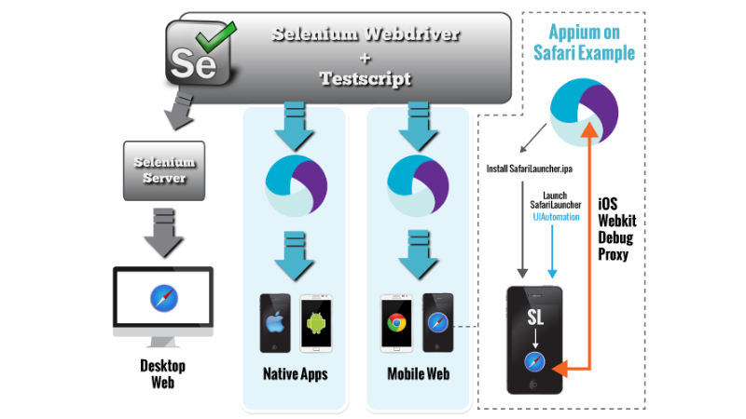

Advantages of Selenium:
- Automated Software Testing saves Time and Money-The code for the same object can be used across different applications. Duplication of work is minimized at every level which saves time. A time savings that translates directly into cost savings.
- Improves Accuracy-In manual testing tester make many mistakes but in automated testing, tests perform the same steps precisely every time they are executed and never forget to record detailed results.
- No scripting skills are required by the end user-No coding skills are required to automate and review the scripts. The scripts are user friendly with good readability.
- Reliability-As the test cases are stored and well maintained, if any error comes, we can easily check against that error. So, reliability is here
- Test scripts can be written in any of these programming languages: Java, Python, C#, PHP, Ruby, Perl & .Net
- Tests can be carried out in any of these OS: Windows, Mac or Linux
- Tests can be carried out using any browser: Mozilla Firefox, Internet Explorer, Google Chrome, Safari or Opera
- It can be integrated with tools such as TestNG & JUnit for managing test cases and generating reports
- It can be integrated with Maven, Jenkins & Docker to achieve Continuous Testing
Drawbacks of Selenium;
- There is no guaranteed support available for Selenium. We need to leverage on the available customer communities
- It is not possible to perform testing on images. We need to integrate Selenium with Sikuli for image based testing
- There is no native reporting facility. But we can overcome that issue by integrating it with frameworks like TestNG or Junit

Conclusion:- Hence we successfully studied Selenium Web Testing Tool.

